機率第一次期中考解答
1.(0.001*0.99) / (0.999*0.02+0.001*0.99) = 1/233
2. With the range given, 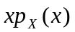 means 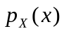 occurs x times in the sum defining E[X]; we could visualize this operation by defining the following array (also remember 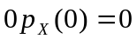);
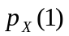 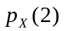 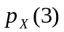 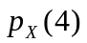 …
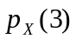 …
…
…
…
Since the sum of the first row is P(X>0), the sum of second is P(X>1), etc.
=> 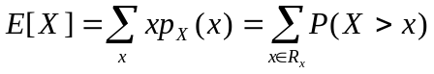
3.
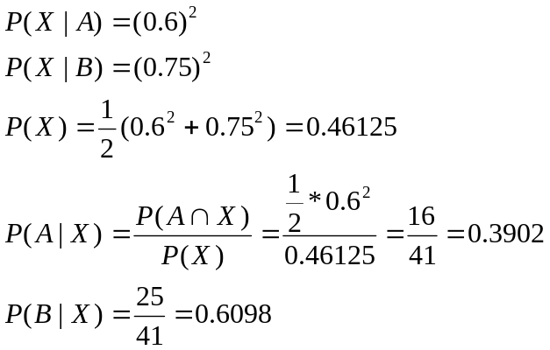

4.
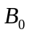: {A中抽出0個紅球}
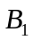: { A中抽出1個紅球}
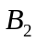: {A中抽出2個紅球}
X: {B中抽出2個紅球}
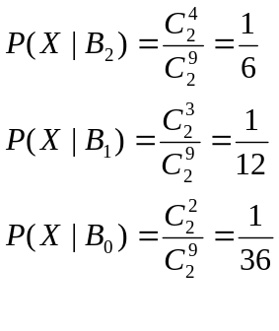
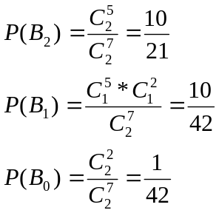
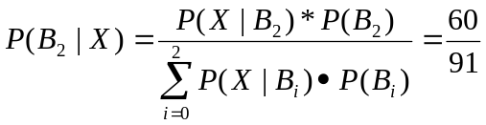

5.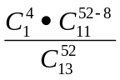

6.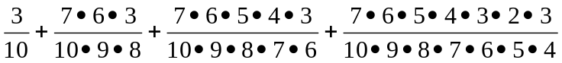

7.(a) 10!
(b) 6! * 5!
(c) 2 * 5! * 5!

8. 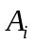:第i對夫妻坐在一起
Ａ:至少有一對坐在一起
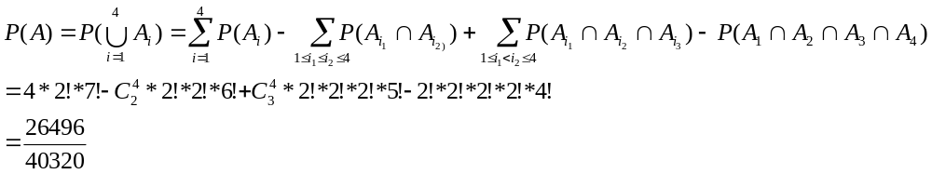
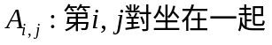(1,2), (1,3), (1,4), (2,3), (2,4), (3,4)
B:至少有二對坐在一起
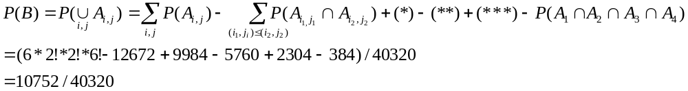P(恰一對坐在一起)=P(A)-P(B)=15744/40320
註:
(1):
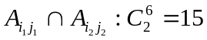
三對: (1,2)-> (1,3), (1,4), (2,3), (2,4)
(1,3)->(1,4), (2,3), (3,4)
(1,4)->(2,4), (3,4)
(2,3)->(2,4), (3,4)
(2,4)->(3,4)
四對: (1,2)->(3,4)
(1,3)->(2,4)
(1,4)->(2,3)
12*2!*2!*2!*5!+3*2!*2!*2!*2!*4! = 12672
(2).(*):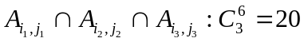
=>三對: (1,2)->(1,3)(2,3)
(1,2)->(1,4)(2,4)
(1,3)->(1,4)(3,4)
(2,3)->(2,4)(3,4)
四對: (1,2)->(1,3)(1,4) , (1,3)(2,4) , (1,3)(3,4)
(1,2)->(1,4)(2,3) , (1,4)(3,4)
(1,2)->(2,3)(2,4) , (2,3)(3,4)
(1,2)->(2,4)(3,4)
(1,3)->(1,4)(2,3) , (1,4)(2,4) , (2,3)(2,4) , (2,3)(3,4) , (2,4)(3,4)
(1,4)->(2,3)(2,4) , (2,3)(3,4) , (2,4)(3,4)
4*960+16*384=9984
(3).(**):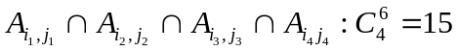
三對: 無
四對: (1,2)->(1,3)(1,4)(2,3), (1,3)(1,4)(2,4), (1,3)(1,4)(3,4)
(1,2)->(1,3)(2,3)(2,4), (1,3)(2,3)(3,4)
(1,2)->(1,3)(2,4)(3,4)
(1,2)->(1,4)(2,3)(2,4), (1,4)(2,3)(3,4), (1,4)(2,4)(3,4)
(1,2)->(2,3)(2,4)(2,4)
(1,3)->(1,4)(2,3)(2,4), (1,4)(2,3)(3,4), (1,4)(2,4)(3,4)
(1,3)->(2,3)(2,4)(3,4)
(1,4)->(2,3)(2,4),(3,4)
15*384=5760
(4)(***):
均四對 6*384=2304

(5)
1*384=384

9.出現6機率5/36 ，7是6/36
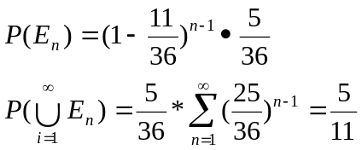

10.
(method 1)
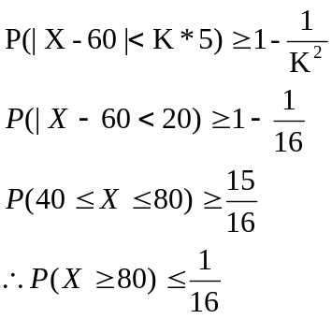
(method 2: Markov’s ineq)
